2018 International Conference on High Performance Computing & Simulation

Apple Ripeness Estimation using Artificial Neural Network

Raja Hamza

*Control and Energ y Management Laboratory N‹itionnl Engineering School o( Sfax,* University of Sfax, Tunisia raja.hamzaHenis.tn

***Abstract—rat* ripeness estimation is an important process that affects its quality and subsequently its marketing. Automatic ripeness evaluation through computer vision system has** been **an innovative topic interesting many researchers as it provides efficient solution to the** slow speed, **time consumption and high cost associated with the manual assessment. In this paper, Artificial** Neural Network (ANN) **classification approach has been investigated to estimate the ripeness of apple fruits based on color.** Several **points** have been **dealt with in this study, namely** the **color features vectors, the learning pedagogy and the structure of the** ANN **classifier in order to obtain the best performance. Dataset used for simulation has been collected and exploited for the training and testing phases: 80** to **of the total images** were **used for training and** 209c **of the total images** were **used for testing the classifier. Training dataset is composed by three classes representing the** three **different stages of** apple **ripeness. Simulation results showed the performance achieved by the ripeness classification system.**

***Index* Z’erms—Neural Network, fruit ripeness, classification, image segmentation, features extraction**

1. INTRODUCTION

The automation of some tasks in the agricultural production cycle has considerably attracted researchers for more than twenty years ago, such as water and pesticide spraying [1], weed control [2], harvesting fruit and vegetables in orchards or greenhouses [3]—[6], crop quality assessment [7], [8], etc. This is tied essentially not only to the lack, the expensive cost and the high time consuming of labors but also to the exponential advancement in data acquisition and storage techniques.

Indeed, the majority of these applications include a com- puter vision system using a digital camera and image analysis techniques. The use of computer vision technology in the agricultural sector is explained by the fact that machine vision based systems are automated, non-destructive and cost- effective. Furthermore, this technology is ideally suited for agro-products inspection and quality assurance. Thus, the food industry is now ranked among the top ten industries using this technology [9].

The major objective of this type of applications is to ensure a good product quality to the consumer. For many crops, one key indicator of quality is its ripeness. Mainly, the maturity of a fruit or vegetable is assessed from its external characteristics which are essentially color, size, texture and shape. The strong correlation between crop color and its maturity makes it widely

978-1-5386-7879-4/18/$31.00 02018 IEEE DOI 10.1109/HPCS.2018.00049

229

Mohamed Chtourou

*Control and Energy Management Laboratory National Engineering Schuol o[ Sfax,* University of Sfax, Tunisia Mohamed.chtourouHenis.tn

used to evaluate maturity for various fruits and vegetables like apples [9], tomatoes [10], watermelons [11], bananas [12],

mangoes [13], citrus [14] and dates [15].

According to the Food and Agriculture Organization of the United Nations FAO-UN database in 2014, apples world production was about 85 million tons fresh fruits and has been reported for 96 countries [16]. So, the apple fruit takes important place among the fruits production in all over the world. Hence, we are interested, in this article, in how to estimate maturity levels of apple fruit using machine learning techniques and more specifically using ANNs since they have been used successfully in several classification applications [17]. In the proposed approach, the ANN training procedure adopts a trial and error based process in order to determine the classifier architecture especially in the choice of the number of hidden neurons. For the feature extraction stage, this paper gives a comparative study between two color features in order to determine the best feature extractor. We propose also to explore the impact of selecting the training samples in the training phase: in a first time by using an ordered learning i.e. the training samples are sorted according to their desired class and then by using a random learning i.e. the training samples are chosen in a random manner. To the best of our knowledge, this study is the first research work, in the fruit ripeness classification field, focusing on the three ANN parameters mentioned previously together in order to achieve the most appropriate criterion for the classification approach and then reach the best performance.

The rest of this article is organized as follows. Section 2 introduces some recent research works related to quality assessment of apple fruit. Section 3 describes the different phases of the synthesis of the proposed apple maturity system. Section 4 discusses the obtained simulation results. Finally, Section 5 presents conclusions and addresses a number of future research suggestions.

1. RELATED WORKS

Applying computer vision techniques to estimate ripeness level of different fruits and vegetables was surveyed by [10] where authors reviewed a number of current research ap- proaches related to the problem of ripeness monitoring and classification for some fruits and vegetables like oil palm,

avocado, waterme1on,etc.... with special interest to tomatoes. This section highlights the problem of ripeness evaluation for apple fruit tackled by some current researches.

In [9j, authors present a system for apple color grading into four classes according to standards stipulated in China. Four images, one for every rotation of 90, were taken from each apple. Seventeen color feature parameters based on the RGB and HIS color spaces were extracted from each apple in the image processing. A back-propagation ANN was built for apple color grading and reached 839a and 76.39c as classification accuracy rates respectively for the training and testing sets.

Authors in [18] used fuzzy logic to classify apples into three grades. Initially apple image database is created. Next each image is analyzed using image processing software where images are first preprocessed and useful features like color and size are extracted from the images. For the color feature, only the mean of the Red component in the RGB color space was used. Apples of different classes are graded into three grades Gradel, Grade2 and Grade3 on the basis of combination of parameters mentioned above.

In [19], authors described two techniques: color image segmentation and fuzzy logic system. Segmentation algorithm was applied to four images captured for each apple fruit from different directions for getting area of interest. Then the mean value of the three primary colors Red, Green and Blue has been calculated and used as inputs to Fuzzy Inference System (FIS) in order to classify apples into ripe, under-ripe and over- ripe categories.

[20] suggested an effective automatic grading system for apple fruits. This technique categorizes apples as red and green apples. In this work, RGB images are converted into HSV images and threshold based segmentation method is used to segment apple images from the background. They reported 1009c accuracy by using kernel function for Support Vector Machine (SVM) classifier.

In [21], authors proposed a multi-features information fu- sion method based on back propagation neural networks and D-S evidential theory to improve the accuracy of apple grading. Firstly, size, shape and color features are extracted from the processed images of apples. Secondly, apples are classified with each kind of feature by BP neural network classifier. Finally, D-S fusion rules of evidences are used to make the decision and achieve the final grading result. The experimental results have shown that the decision information fusion method based on size, shape and color features has good performance on accuracy (87.509c) compared to the color- based (70.00%) and size and shape-based (75.00%) method in apple grading.

To conclude, several research have addressed the apple ripeness classification problem which is still an attractive research area in the computer vision field. Most of the ap- proaches proposed in these research start with segmenting the fruit image in order to extract the region of interest and then calculate image features from that segmented image which are further used as inputs for the classifier. As previously

outlined in the related works, ANN, fuzzy logic and SVM are the commonly used techniques for the classification task. The major goal is to obtain the highest classification accuracy of the implemented classification approach. In this context, we introduce in this article a method for the apple maturity classification for images belonging to three classes (under-ripe, turning ripe and ripe) using ANN. A detailed description of this method is presented in the next section.

1. THEPROPOSED APPLE MATURITY SYSTEM

This research aims to assess a ripeness stage to an apple image from an image dataset. Like most pattern recognition systems, the proposed apple maturity system consists of four phases namely pre-processing, feature extraction, training and testing phases. Proposed system architecture is described in figure 1.

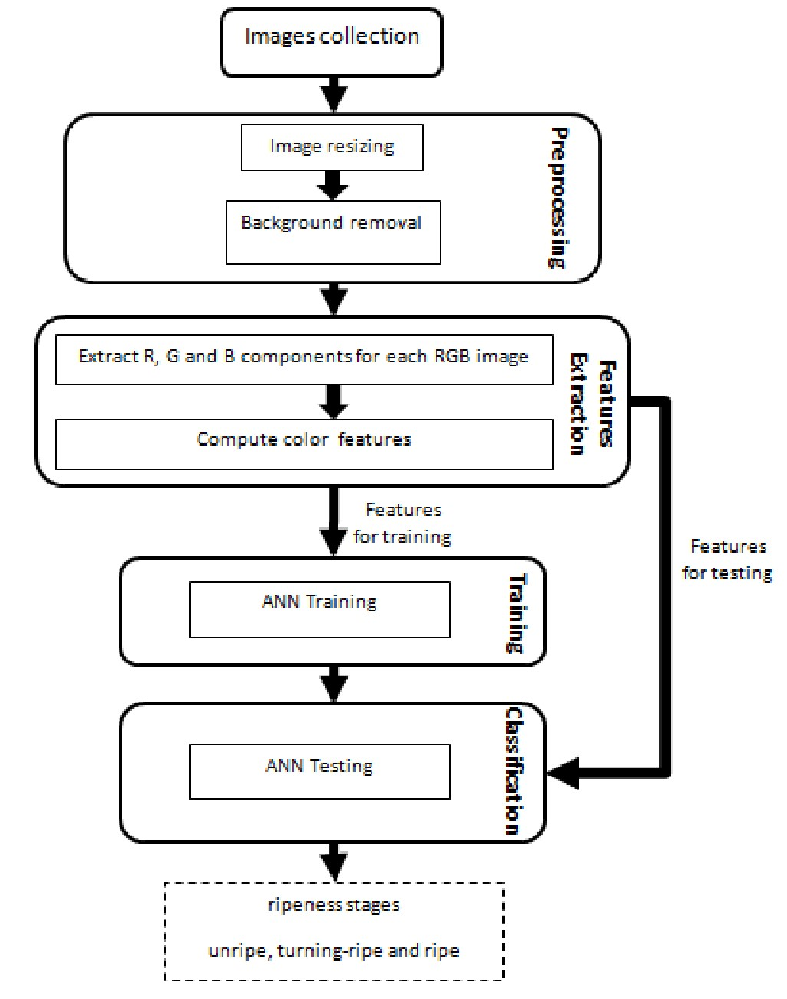

Fig. 1. Architecture of the proposed apple maturity system

1. *Pre-processing phase*

The proposed approach resized all images to 250x250 pixels in order to have all images in the same conditions during the pre-processing phase. Then each image is converted from RGB to L*a*b* color space. The use of L*a*b* color space in the image segmentation step can be justified by the fact that the a* component in this space represents color between red and green which corresponds exactly to the color of apple fruit in his different maturity levels. After that, thresholding is used to

230

remove background according to b* component followed by some morphological operations applied to the binary image. These operations are necessary to fi11 the small holes and clear isolated blobs. Finally, an RGB image is reconstructed with black color for the background. Figure 2 shows examples of background subtraction for apple image in each ripeness class.

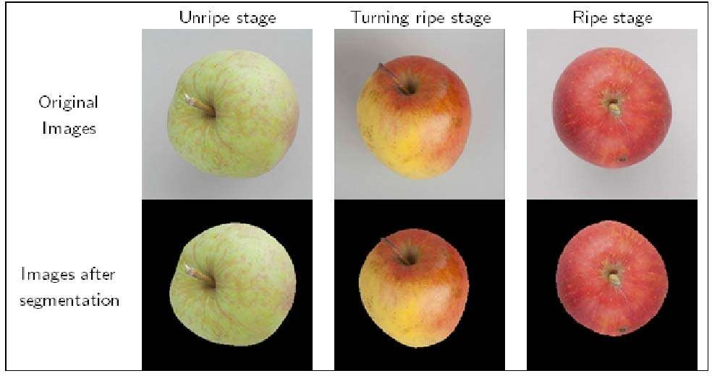

Fig. 2. Examples of images background removal for the three classes

1. *Features extraction phase*

The fruit surface color is the most important indicator of the apple ripeness level that can be expressed using several standard color spaces. The most used ones in image processing for agricultural applications are RGB (Red, Green, Blue), HSI (Hue, Saturation, Intensity) and CIELAB [22]. Color features used in this study are the mean *‹M p, My, M g),* the variance (Up, Up, Ug), the chromaticity (r, y, *b) ,* the standard deviation

1. *Training phase*

Research concerning fruit ripeness used various classifiers, such as ANN, K-means and fuzzy logic approaches [10]. In this study, a three layered neural network was building to assess maturity level to the apple. The inputs of the ANN are the color features and the desired outputs are the three classes of apple ripeness. For each image features a desired output vector is constructed where’1’ is fixed for the correct output neuron and ’0’ for all others output neurons. The neuron connection and bias weights are initialized with fifty small random values then values given minimum error between desired outputs and computed outputs are selected. The ANN was trained using back-propagation algorithm and the sigmoid function as activation function. More details on the description of ANN can be found in [23]. It is difficult to choose the best number of hidden layers nodes for a given problem. There are two techniques to solve this problem: constructive and pruning algorithms [24]. The first one starts with a small structure, usually a single hidden neuron and dynamically allows the network to grow by adding neurons as needed until a satisfactory solution is found. The second approach, referred to as pruning algorithm, starts with a great structure and eliminates hidden neurons during the training step. Then, in this work, the constructive training approach is adopted. So, an exploration study has been done to select the adequate number given best results. The training process is stopped when the mean square error MSE given in Eq.6 reach a predefined value called c.

*{SD p, SDK, SDg)* and the skewness *(S p, Sq, Sg)* of the three primary colors R,G and B extracted from the RGB image

*MSE ——*

(6)

as following for the red channel:

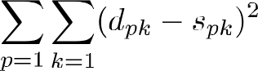

1

*M p R*

(1)

Where *P* is the number of samples, K is the number of outputs neurons, dp and .sp are the desired and the computed outputs of the network for the *p”* pattern.

1. *Testing phase*

Where *R ——* fi;, fi; is the red component of the pixel i

i=1

and n is the total number of pixels in the image.

1

The performance of the recognition system is measured by determining the classification accuracy rate on training and

testing sets defined by the ratio between the number of true

*•° —— -: Z(° , — Mp)*

i= 1

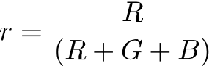

(2)

(3)

classification by the total number of images in the training and testing sets respectively as shown in Eg.7:

*Ar.curacp ——* Number of correctly classified images .

Total number of images

The three chromaticity variables r,g and b must verify the following equation r + p + h = 1.

(7)

To summarize, the proposed system accomplishes the fol- lowing steps:

Stepl: Create the MLP composed by a given number of

*S D ——*

(4) hidden neurons;

Step2: Initialize the neurons connection and bias weights with selected random values;



*; Z(°•— M R)* 2

Step3: Train the MLP using the back-propagation algorithm

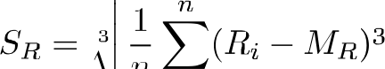

;-1

(5)

with the training dataset. Stop training when MSE reach e.

2ñ1

Step4: Store the final connection and bias weights of the MLP;

Step5: Test the MLP with the testing set; Step6: Calculate the accuracy of the classifier.

1. SIMULATION RESULTS

Simulations are accomplished with a PC type Intel Core i3-2350MH2.30 GHZ CPU and 4 GB memory. The proposed approach is designed with Matlab R2016a running on Win- dows 7.

The database used for simulation was based on six hundred images for fruit apple collected from the website [25]. The collected data was divided into 3 classes (200 images per class) representing the different stages of apple ripeness: unripe, turning-ripe and ripe. For unripe stage, the fruit surface is completely green; however for the ripe stage the fruit surface is completely red. For turning-ripe stage, the fruit surface contains different colors from green to red. The ANN was trained with 480 examples (809c of the image dataset) and tested with 120 examples (209c of the image dataset). In this work, two learning processes are adopted which are ordered and random learning. For the ordered learning, training exam- ples are sorted according to their desired class that is to say they are presented 160 examples for the first class followed by 160 examples for the second class and finally 160 examples for the third class. However, for the random learning, the training examples are presented in a random manner. Both learning processes used the same initial weights values. Two types of features have been considered. Firstly, the average values *(M p, My, M p),* the variance (Vp, *Vz, Vg)* and the chromaticity (r, p, *b)* of the three primary colors R, G and B were used (First features group). Secondly, the average values (Mp, *My, Mg),* the standard deviation *(SD p, SD z, SD g)* and the skewness *‹SPR Sq, S g)* of the three primary colors R, G and B were used (Second features group). The number of input neurons is equal to the dimension of the features vector. The training phase is stopped when the MSE threshold e is lower or equal to 10* 2.

Tables I and II present the simulation results obtained by the proposed approach using back-propagation ANN with mean, variance and chromaticity features described previously by ordered and random learning respectively. However, Tables III and IV present the simulation results using back-propagation ANN with mean, standard deviation and skewness features by ordered and random learning respectively.

It can be seen from the four tables that the classification accuracy on both the training and testing sets increases while the hidden layer nodes increase, then did not change even by continue incrementing it. Therefore, the network with a struc- ture of 9-18-3 was selected from Tables I, II and III while the network with a structure of 9-12-3 was selected from Table IV because these two structures gives the highest accuracy with a relatively small network structure. Subsequently, the number of hidden neurons is no longer incremented to avoid the ANN

TABLE I

S IMULATI ON RESULTS USING BACK-PROPAGATION ANN WITH MEAN,

**VARIANCE AND CHROMATICITY FEATURES AND ORDERED LEARNING.**

|  |  |  |  |  |
| --- | --- | --- | --- | --- |
| **Ordered learning** | | | | |
| *MLP Stricture*  *{input-hidden-autput)* | *Number*  *of Itera- tions* | ***(second)*** | *Accuracy*  *an the training* | *Accuracy*  *on the testing* |





|  |  |  |  |  |  |  |
| --- | --- | --- | --- | --- | --- | --- |
| 9-4-3 | 223 |  | 3.13 | | | 87.5 | | 86.66 |
| 9-6-3 | 246 |  | 3.70 |  | 87.5 | 86.66 |
| 9-8-3 | 235 |  | 3.29 |  | 87.5 | 86.66 |
| 9-10-3 | 483 |  | 7.62 |  | 85.83 | 86.66 |
| 9-12-3 | 342 | | | 4.99 | | | 85.83 | | 86.d6 |
| 9-14-3 | 537 |  | 7.60 |  | 89.16 | | 93.33 |
| 9-16-3 | 391 | | | 5.59 | | | 87.50 | | 93.33 |
| 9-18-3 | 538 | | | 7.81 | | | 90.83 | | 93.33 |
| 9-20-3 | 532 | | | 7.72 | | | 90.83 | | 93.33 |
| 9-22-3 | 473 | | | 6.82 | | | 90.83 | | 93.33 |
| 9-24-3 | 624 | | | 10.59 | | | 90.83 | | 93.33 |

TABLE II

S IMULATI ON RESULTS USING BACK-PROPAGATION ANN WITH MEAN,

**VARIANCE AND CHROMATICITY FEATURES AND RANDOM LEARNING.**

|  |  |  |  |  |
| --- | --- | --- | --- | --- |
| Raadom leamiag | | | | |
| *M*AP *Sir* zi *clnre*  *(input-hidden-oufi ut)* | ***Number***  *of Itera-*  *fionc*  ***(epochs)*** | *lfime*  *{secand)* | *Acc*u*racy*  *on* fAe *training set (to)* | *the testing set (fi'o)* |

|  |  |  |  |  |  |  |  |  |
| --- | --- | --- | --- | --- | --- | --- | --- | --- |
| 9-4-3 |  | 159 |  | 2.14 |  | 94.58 |  | 95.00 |
| 9-6-3 |  | 139 |  | 2.03 |  | 94.58 |  | 95.00 |
| 9-8-3 | | | 140 | | | 2.02 | | | 94.58 | | | 95.00 |
| 9-10-3 | | | 144 | | | 2.11 | | | 94.58 | | | 95.00 |
| 9-12-3 | | | 151 | | | 1.98 |  | 95.62 |  | 97.50 |
| 9-14-3 | | | 149 | | | 2.23 | | | 95.62 | | | 97.50 |
| 9-16-3 | | | 169 |  | 2.30 | | | 95.62 |  | 97.50 |
| 9-18-3 | | | 150 |  | 2.40 | | | 97.08 | | | 98.33 |
| 9-20-3 |  | 157 |  | 2.30 |  | 97.08 |  | 98.33 |
| 9-22-3 |  | 160 |  | 2.48 |  | 97.08 |  | 98.33 |
| 9-24-3 |  | 155 |  | 3.30 |  | 97.08 |  | 98.33 |

TABLE III

S IMULATI ON RESULTS USING BACK-PROPAGATION ANN WITH MEAN, STANDARD DEVIATION **AND** SKEWNES S FEATURES AND **ORDERED LEARNING.**

|  |  |  |  |  |
| --- | --- | --- | --- | --- |
| Ordered learning | | | | |
| *M*AP *Simcure*  *(input-hidden-output)* | *Number*  *of fteza-*  lions  ***(epuchs)*** | *time*  *{secand)* | *Accuracy*  *on the training set (to)* | *Accuracy*  *on the testing set (9’)* |

|  |  |  |  |  |  |  |  |  |
| --- | --- | --- | --- | --- | --- | --- | --- | --- |
| 9-4-3 | | | 39 | | | 0.52 |  | 84.16 | | | 80.00 |
| 9-6-3 | | | 41 | | | 0.64 | | | 82.70 | | | 80.00 |
| 9-8-3 | | | 41 | | | 0.61 | | | 82.70 | | | 83.33 |
| 9-10-3 | | | 42 | | | 0.67 |  | 82.70 | | | 80.00 |
| 9-12-3 | | | 52 | | | 0.80 | | | 85.83 | | | 83.33 |
| 9-14-3 | | | 46 | | | 0.74 | | | 85.83 | | | 83.33 |
| 9-16-3 | | | 44 | | | 0.71 | | | 80.83 | | | 83.33 |
| 9-18-3 | | | 51 | | | 0.73 | | | 84.16 | | | 83.33 |
| 9-20-3 |  | 42 |  | 0.62 |  | 84.16 |  | 83.33 |
| 9-22-3 |  | 41 |  | 0.62 |  | 84.16 |  | 83.33 |
| 9-24-3 |  | 45 |  | 0.63 |  | 84.16 |  | 83.33 |

2?2

TABLE IV

SIMULATION RESULTS USING BACK-PROPAGATION ANN WITH MEAN, STANDARD **DEVIATION AND** S **KEWNESS FEATURES AND RANDOM LEARNING.**

|  |  |  |  |  |
| --- | --- | --- | --- | --- |
|  | | | | |
| *MLP S*f r*uct*zi*re* | *of ltera-* |  | *Accuracy*  on *the training* | *Accuracy*  *on the testing* |



 

|  |  |  |  |  |  |  |  |  |
| --- | --- | --- | --- | --- | --- | --- | --- | --- |
| 9-4-3 |  | 24 |  | 0.31 |  | 91.87 |  | 92.50 |
| 9-6-3 |  | 24 |  | 0.37 |  | 91.87 |  | 92.50 |
| 9-8-3 |  | 32 |  | 0.53 |  | 93.12 |  | 94.16 |
| 9-10-3 | | | 28 | | | 0.45 | | | 93.12 | | | 94.1d |
| 9-12-3 |  | 25 |  | 0.43 | | | 94.1fi | | | 96.66 |
| 9-14-3 |  | 23 |  | 0.35 | | | 94.16 | | | 96.66 |
| 9-16-3 | | | 23 | | | 0.48 | | | 94.16 | | | 96.66 |
| 9-18-3 | | | 23 | | | 0.34 | | | 94.16 | | | 96.66 |
| 9-20-3 | | | 24 | | | 0.36 | | | 94.16 | | | 96.66 |
| 9-22-3 |  | 22 |  | 0.30 |  | 94.16 |  | 96.66 |
| 9-24-3 |  | 22 |  | 0.30 |  | 94.16 |  | 96.66 |

overfitting that is, its classification accuracy on the training set is very high while its classification accuracy on the testing set is unacceptable. Our results share a number of similarities with X. Zou et al.s findings [9].

For the learning pedagogy, a higher accuracy on both the training and testing sets is reached compared with the ordered learning. Therefore, with the first features group, the accuracy reaches 97.089o and 98.339a respectively on the training and testing sets using random learning (Table II) whereas it is lower compared with the ordered learning where it reaches 90.839a and 93.33% respectively on the training and testing sets (Table I). These findings are also confirmed with the second features group where the accuracy reaches 94.169a and 96.669c with the random learning (Table IV) versus 84.169c and 83.339c with the ordered learning (Table **III).** Besides, a reduced training time is noticed with the random learning. For each ANN structure and for both the first and second features groups, the training time with random learning is less than the one with ordered learning.

Best accuracy on the training and testing sets is obtained with the first features group 97.089s and 98.33% versus 94.169a and 96.66% with the second features group. The first features group was used in this work in order to compare our results with those reported by authors in [9] in which the mean, the variance, the chromaticity and color histogram features (17 features) were used to classify apple to four classes. We found higher accuracy values than those founded in [9] reaching 839c and 76.39c on the training and testing data. The second features group was used in [10] for classifying tomato ripeness stages. The approach proposed in [10] used Principal

multi-class SVMs algorithm with linear kernel function, and ripeness classification accuracy of 849c using LDA algorithm.

1. CONCLUSION

In this paper, an artificial neural network classifier has been designed and applied in apple ripeness level assessment. The proposed approach includes four steps. Thresholding segmen- tation method and some morphological operations are used in the **first** step for a region of interest extraction. In the second step, color-based features are drawn from the segmented apple images and divided into training and testing data. The classifier training parameters are the object of the third step. In the last step, the classification is accomplished using the trained ANN.

An essential finding in this study is that the construction of the neural network is an empirical process and requires several trials to find the suitable parameters giving the best performances of the neural classifier. These parameters in- clude weights initialization, number of hidden neurons, MSE, numbers of iterations, etc. The learning pedagogy affects also the accuracy rate. Simulation results prove that adopting a random learning give higher accuracy compared by the ordered learning.

The limitation faced in this research is the collection of the images dataset that’s need to be larger as the accuracy of the ANN classifier increases by increasing the number of images per training class. Moreover, as far as we know, no online images databases are available on crop classification similar to databases relatives to face recognition, handwritten characters recognition fields that will be very useful in the testing and comparison of newly developed applications.

Various research directions and challenges could be con- sidered for future research. Firstly, the approach proposed in this article can be applied to detect ripeness stage for images containing apple on trees in order to automate the whole process of harvesting ensured by agricultural robots.

Another direction of research concerns the application of other classification approaches like fuzzy logic in apple ma- turity estimation in order to compare the advantages and limitations of using each of them.

In additional, in this study we have consider some color features in the **RGB** color space. Future studies can take into account other color spaces and can also involve other external features like shape and texture that will lead to better fruit quality assessment.

REFERENCES

[1 j P. J. Sammons, T. Furukawa, and A. Bulgin, “Autonomous pesticide spraying robot for use in a greenhouse,” in *Australian Conference on Robotics and Automation,* 2005, pp. 1—9.

Components Analysis (PCA) in addition to Support Vector

Machines (SVMs) and Linear Discriminant Analysis (LDA) algorithms for feature extraction and classification, respec-

[2]

D. Slaughter, D. Giles, and D. Downey, “Autonomous robotic weed control systems: A review,” *Computers and electronics in agriculture,* vol. 61, no. 1, pp. 63—78, 2008.

tively. Experimental results has obtained ripeness classification accuracy of 90.809a, using one-against-one (OAO) multi-

[3] A. Jimenez, R. Ceres, and J. Pons, “A survey of computer vision methods

for locating fruit on trees," *Transactions oy I AsAz,* vol. 43, no. 6, p.

1911, 2000.

class SVMs algorithm with linear kernel function, ripeness classification accuracy of 84.809ausing one-against-all (OAA)

[4l

C. W. Bac, E. J. Henten, J. Hemming, and Y. Edan, “Harvesting robots

for high-value crops: State-of-the-art review and challenges ahead'’

*Journal of Field Robotics,* vol. 31, no. 6, pp. 888—911, 2014.

233

